**Internationalization**

* Also known as i18n as there are 18 characters between i and n.
* If we want to create a website which should display text based on the country. For example if the person is accessing website from the France, it should display text in French and if the person belongs to Germany then it should display text in German.
* So depend upon different countries we have different languages and since we have different languages the caption or the text that should be shown on the website should be different.
* To achieve this we can use a concept of internationalization i18n.

**Steps for internalization implementation**

1. Create i18n node of type sling:folder.

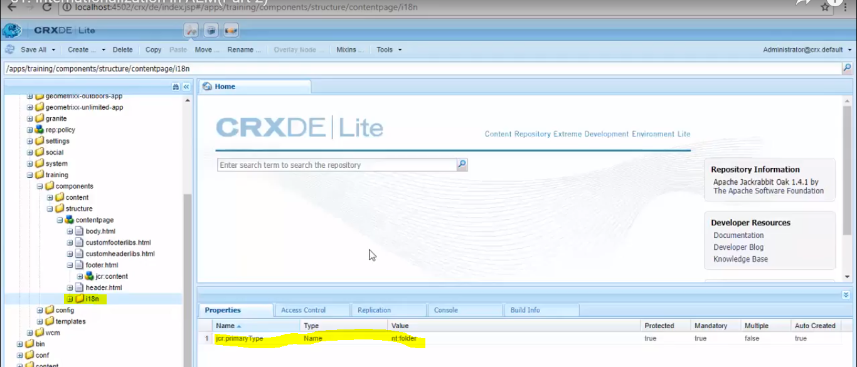

1. Create node with name as language code (ISO code) of the language of type sling:folder.Ex: fr for French and de for Germany. Add 2 properties in this node. jcr: language and it's value of language code and add mixin type as mix:language.

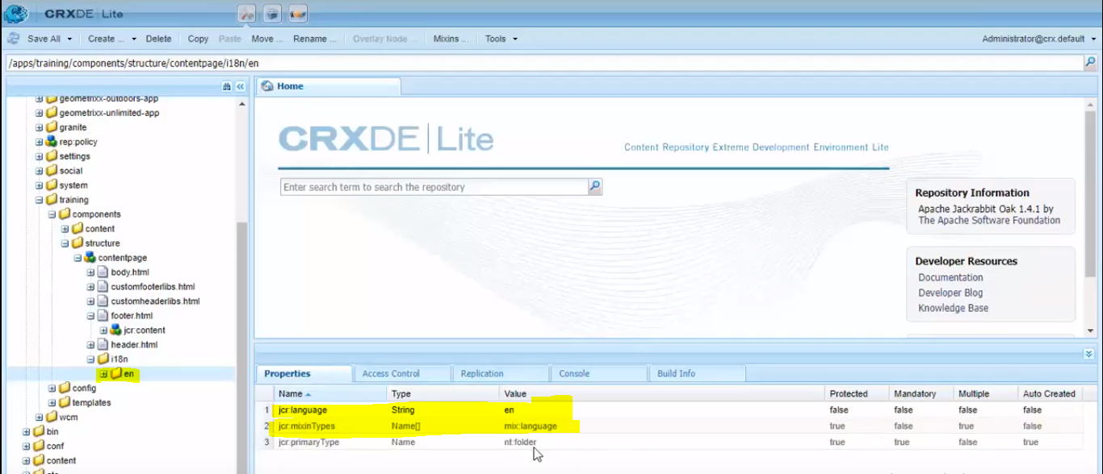

1. Create child node of type sling:messageEntry with properties sling:key and sling:value.

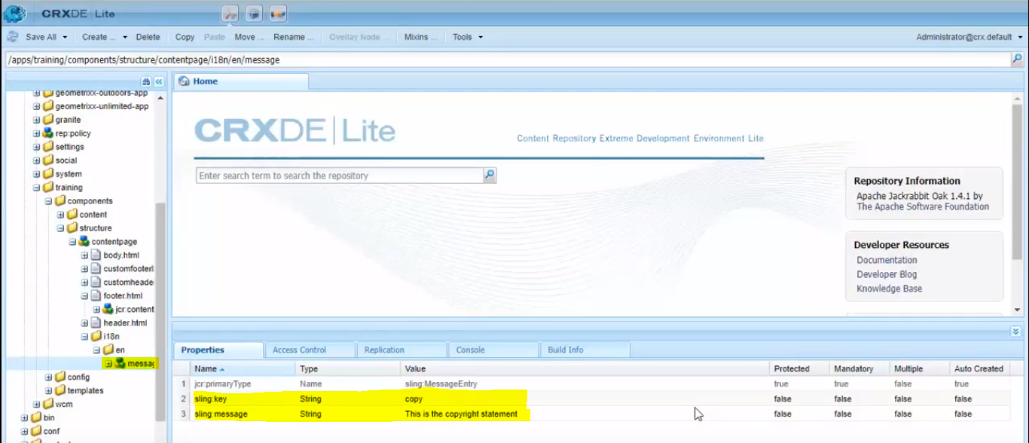

1. sling:key would be any name and message would be the text for the particular language.

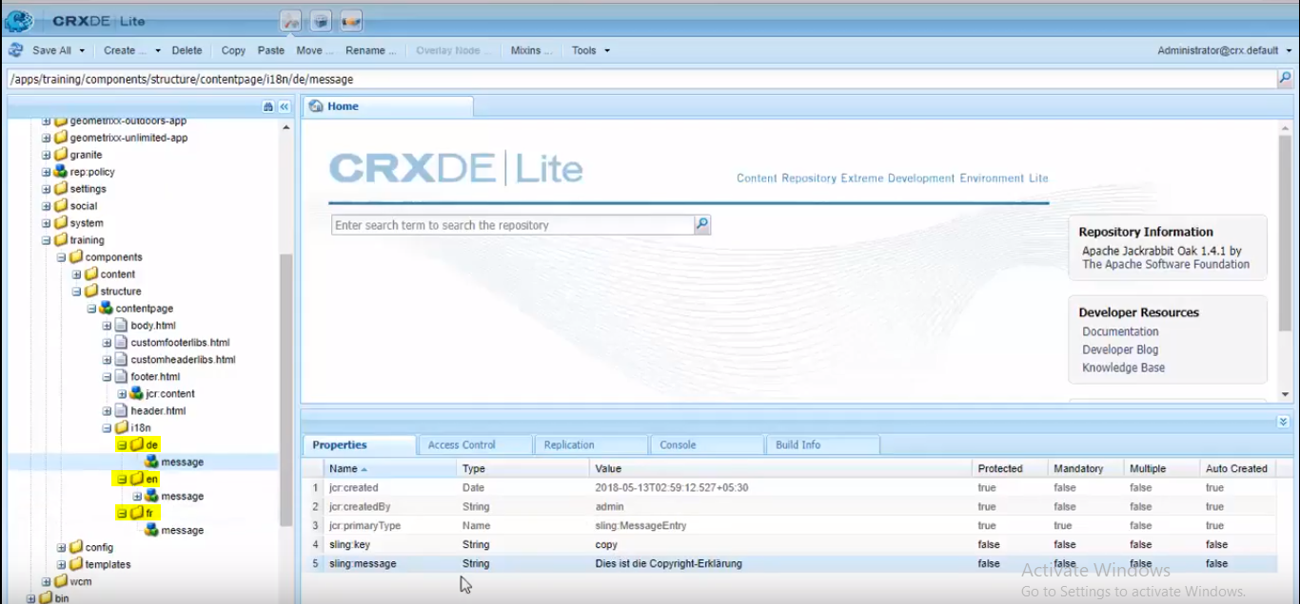

**Code snippet**

<span class="text-uppercase text-muted">${"copy" @ i18n, context='html'}</span>

Here “copy” is the sling:key value and @i18n specifies that the string is i18n key

When different language pages or opened, different message/text would be displayed, based on the values provided in the message entries.

**NOTE:** Scope of the internalization is limited to the folder/component where you create the i18n folder.

Ex: If the i18n folder is created under some component, its limited to that particular component alone.